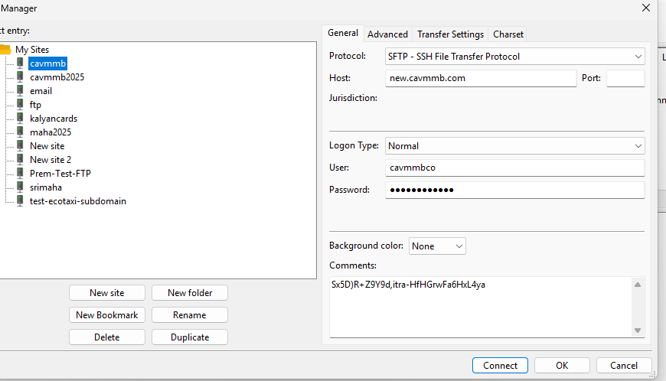

Sx5D)R+Z9Y9d,itra-HfHGrwFa6HxL4ya

new.cavmmb.com

cavmmbco

php artisan serve --host=127.0.0.1 --port=5000

http://localhost:5000/api

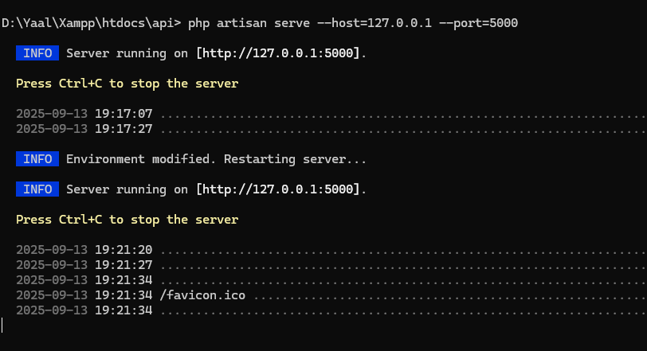

http://localhost:5000/api

<http://localhost:5000/api/loginn?email=t@test.com&password=123>